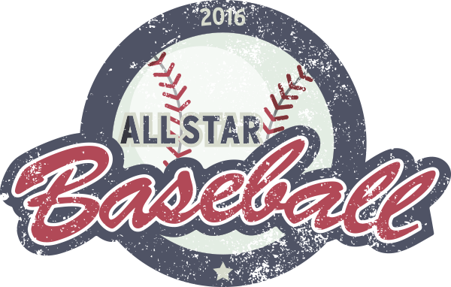
Southern Counties PeeWee All-Star Team – Tryout Registration 2019

Bring this form to Tryouts with tryout fee of $20. Players who are successful in making the team will be required to pay an additional fee, to be determined, to cover uniform & tournament fees.
Cheques made out to SCBA.
PLAYER INFORMATION |  |  | FEMALE |  | MALE
Given Name |  |  | Date of Birth | DD | MM |  | YEAR
Surname |  |  | Postal Code
Address of Residence |  |  |  | Town
Allergies / Medical Conditions

PLAYER HISTORY | Association Played for;
Positions Played
Hitting | Right |  | Left |  | Switch |  | Pitching Experience
2019 Coaches Name |  | Phone:

PARENT / GUARDIAN INFORMATION |  | Home Phone
Given Name |  | Surname
Email |  | Cell Phone

- I hereby give my consent that my child, or ward, can register & play for the Southern Counties Baseball Association.
- I agree to abide by the rules, regulations, policies & decisions of the SCBA & its affiliates.
- I understand that SCBA & its affiliates are not responsible for my child or any injuries that he/she may incur. In the event no one can be contacted, team management will have my child taken to the hospital if deemed necessary.

SIGNATURE |  | DD | MM | YEAR
PRINT NAME |  | DATE

OFFICE USE ONLY | CHEQUE NO. | # | CASH |  | $
SCBA SIGNATURE |  |  | DATE | DD | MM | YEAR

